ANNUAL GENERAL MEETING
TUESDAY 14th JUNE 2022 6:30pm
Church Bar, Chester

Minutes

- Apologies – 15 members

Attendees – 19 members

Declaration of conflicts of interest –Ann Dytor Walsh (treasurer) is related to Rhiannon Bevan (Office Manager, employee). The charity commission has been informed and mitigations in place to manage this.

- Confirmation of Minutes of the last AGM 2021
These were approved as a correct record.
- Chair’s Report presented by Chris Mann. Full text below.
Thanks were given to outgoing chair, Chris Mann, for her work with CSASS.
- Election of Officers for 2022 - 2023
Chair
Position vacant – key duties of the chair will be shared by other trustees in the interim
Secretary
Nominated…. Cathy Powell
Seconded …. Lorraine Pate
Elected …. Barbara Carter
Treasurer –
Nominated…. Cathy Powell
Seconded …. Chris Mann
Elected…. Ann Dytor Walsh
- Treasurer’s Report presented by Centre Manager. Slide below.
Appointment of Independent Auditor : this process is in hand and an announcement will be made at an appropriate time
- Centre Manager’s Report presented by CSASS staff. Slides below.
- Our move to CIO. Barbara Carter presented the trustees proposal for CSASS to move to becoming a CIO, in line with expectations of the Charity Commission, our umbrella bodies and major funders. Slides below. With one abstention, it was agreed to dissolve Chester Sexual Abuse Support Service, the unincorporated charity (registration number 1133564])], at a date to be determined by the trustees, and to transfer all remaining assets to Chester Sexual Abuse Support Service CIO, the charitable incorporated organisation (registration number to be confirmed)
- People Matter launch presented by Lorraine Pate and Cathy Powell. Slide below.

3. Chair’s report
June 2022

Good evening! May I wish you a very warm welcome to the CSASS AGM 2022, which we are delighted to be able to hold in person, in this great venue and with some fun stuff to elevate what could otherwise be a bit of a dull gathering for the formal AGM! Thank you for coming along!
My name is Chris Mann and I am the Chair of the Board of Trustees of CSASS, and I would like to share my short report on last year’s activities with you.
The last year, whilst no longer completely dominated by Covid and the restrictions it brought, was, nevertheless, lived within that context.

The Board of Trustees has continued to meet quarterly as a formal full board, but having learned how to do this remotely in Covid times, we have adopted the approach of holding our formal board business meetings online, enabling greater flexibility for trustee attendance, as we seek to encourage greater diversity on the board, and between those meetings the Trustees have been meeting face to face in a more informal way to discuss a number of issues - the efficient interface between strategic and operational working at CSASS, gender identity matters, equality and diversity throughout the organisation, and sustainable recruitment and succession planning. I’d like to take this opportunity to thank my fellow Trustees for their hard work and commitment to CSASS and for their support for me personally as Chair. I am sure we are all well aware of the increasingly tough environment for charities, financially, but also in terms of eliciting volunteer support, so thank you for your perseverance and dedication. During the year we said farewell to trustees, Liz Temple Murray and Gillie O’Rourke, and we thank them for their time and input and wish them well going forward. We were fortunate to be able to welcome to the board, Lorraine Pate, a very experienced counsellor, Dawn Llewelyn, a Chester university academic working in the area of gender issues, and Barbara Carter, with vast experience in education and in particular safeguarding, who has taken the role of Secretary; they bring invaluable wisdom and energy to the CSASS board. And as I write we have a number of people interested in also joining the board, which is great news!

As we are all aware, as a result of Covid restrictions, the staff and volunteers of CSASS had to swiftly review and alter working patterns - operating the Supportline and Livechat from home, employing virtual counselling rooms, and phone counselling from home too. However, as restrictions eased, we moved toward a blended model of service delivery, and this saw a mix of remote and face to face working. During the year the work of CSASS has benefitted from Sarah taking a lead with the Supportline, and Georgia, recruited through the Kickstart scheme, was a welcome extra pair of hands! It is the incredible volunteers and freelancers who ensure the offer CSASS is able to make to survivors of sexual violence and abuse, possible, and I would like to pay tribute to each and every one of them; thank you on behalf of so many whose lives have been enabled and improved. But, of course, all of us volunteers and freelancers need inducting, training, organising, supporting, and for that I must salute Suzanne, Kathryn, Rhiannon, and of course the hinge-pin, Alison, for the professionalism and dedication they exhibit and maintain day in day out - thank you.

And while I am expressing the Board’s gratitude may I also thank our funders, big and small, without whose financial help CSASS would not be able to continue to provide vital support for survivors of rape and sexual abuse. Alison and Ann will provide more detail, but whilst funding in the charitable sector is always uncertain, we were supported through emergency Covid funding, and have been in receipt of Ministry of Justice and Lottery funds, to name but two, enabling us to offer counselling, groupwork sessions, phone calls, LiveChat, and support via our facebook community. CSASS has also done outreach and campaigning work, seeking to challenge the culture in society which allows sexual violence and abuse to continue. However, the needs of the people we seek to support do not lessen, so everyone at CSASS must continue to ensure we engage creatively, looking for new opportunities and partnerships, and constantly supporting each other as we strive to challenge the causes of sexual abuse and violence, and mitigate the impact of them on the lives of individuals.

Finally, on a personal note, this will be my last AGM as Chair. After some 5½ years’ involvement with CSASS as a board member, Secretary and, for 3 years, Chair, I feel the time is right for me to stand down, to make way for fresh ideas, and to allow me to tend to some demands in my own life. I have very much enjoyed my involvement with the charity and I am proud of the difference CSASS is able to make. It has been a challenging time for everyone, and CSASS is no exception, but despite the challenges we have thrived, increased our income and staff and volunteer base, and been able to meet the growing demand for our services supporting survivors of rape and sexual abuse, alongside raising awareness of the causes of sexual violence.

The role of chair of the board of trustees of CSASS is a tremendously rewarding one and by far the most important element of the role of Chair is a commitment to the core purpose of CSASS, pursuing the shared vision for its future, and the creation and maintenance of a working environment, which enables everyone to play to their strengths, taking responsibility for their individual contributions, so that the sum, which is CSASS and its positive impact, is far greater than its parts. I hope I have contributed positively. I believe as I leave CSASS it is in a strong position to face the future, and I know I leave it in committed and capable hands.

I dearly wish we lived in a world where an organisation such as CSASS did not need to exist, but I fear that is still a long way off. So, until then we must redouble our efforts to raise awareness of the insidious and invidious attitudes, words and actions that creep through our society, and result directly, and indirectly, in deep rooted emotional, mental and physical harm to so many people. We must find the courage to challenge such behaviour and educate for its removal, whilst striving to provide and maintain quality support for survivors.

You, we, each play an integral role in enabling CSASS to do these things, and we can be proud that it does them well! Thank you for being part of CSASS, and allowing me to share the endeavour with you. My very best wishes to you personally, and to CSASS going forward.

Chris Mann
Chair CSAAS
June 2022

5. Treasurers Report
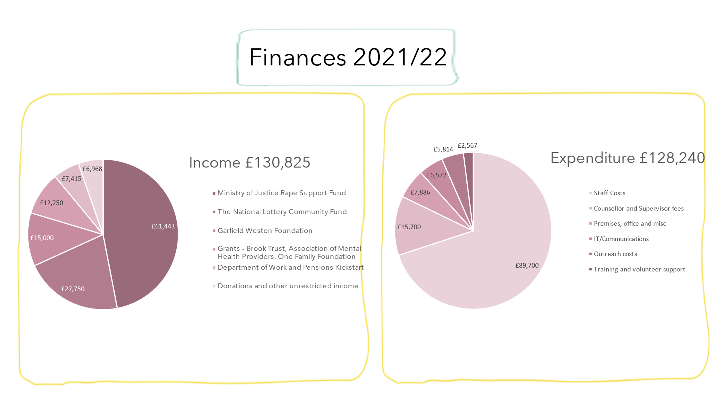

6. Centre Manager Report – Annual Impact report slides
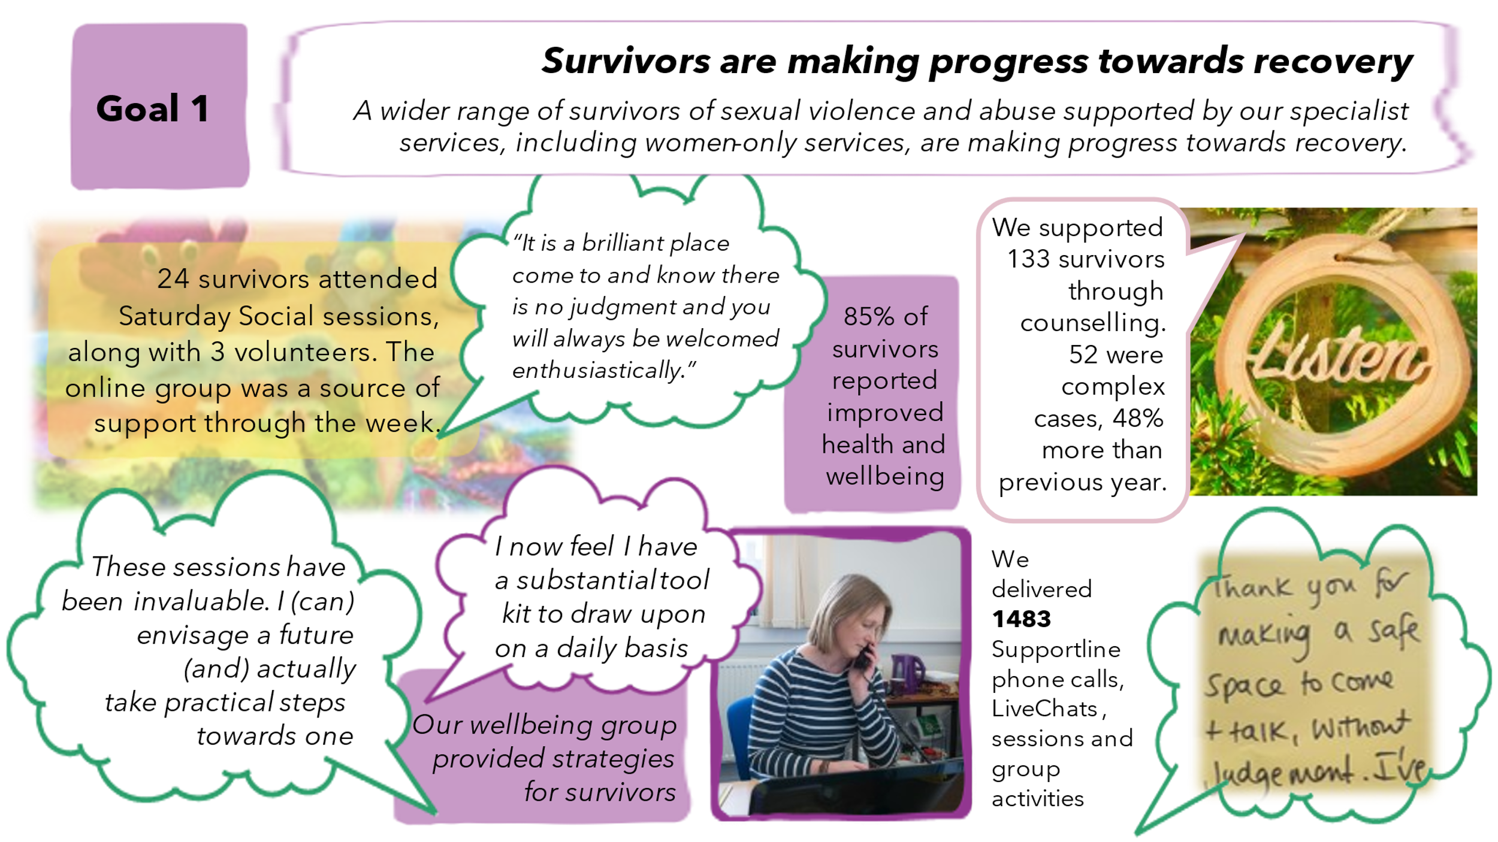

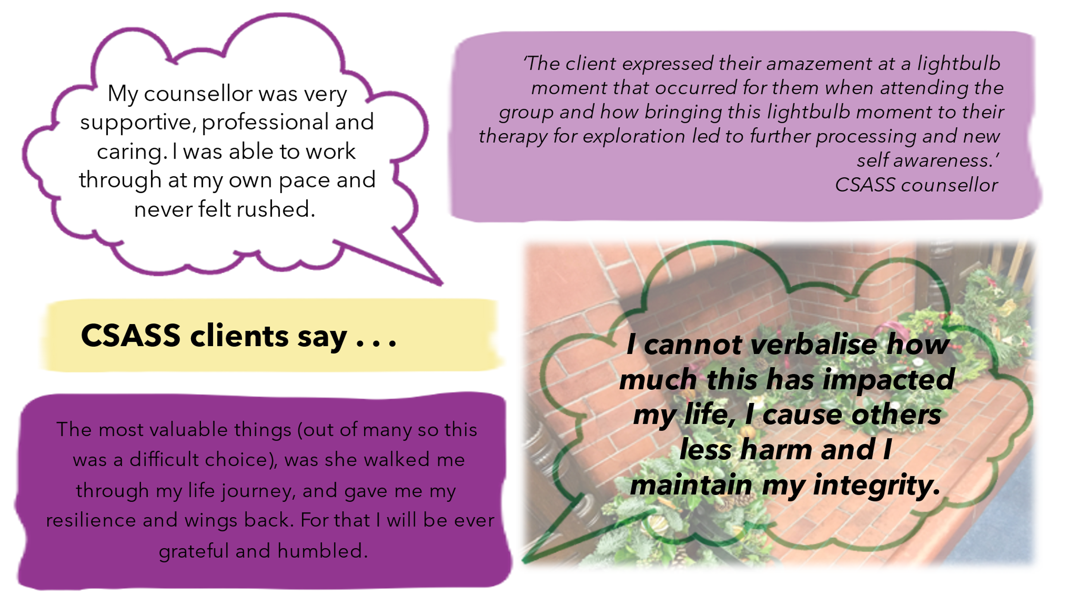

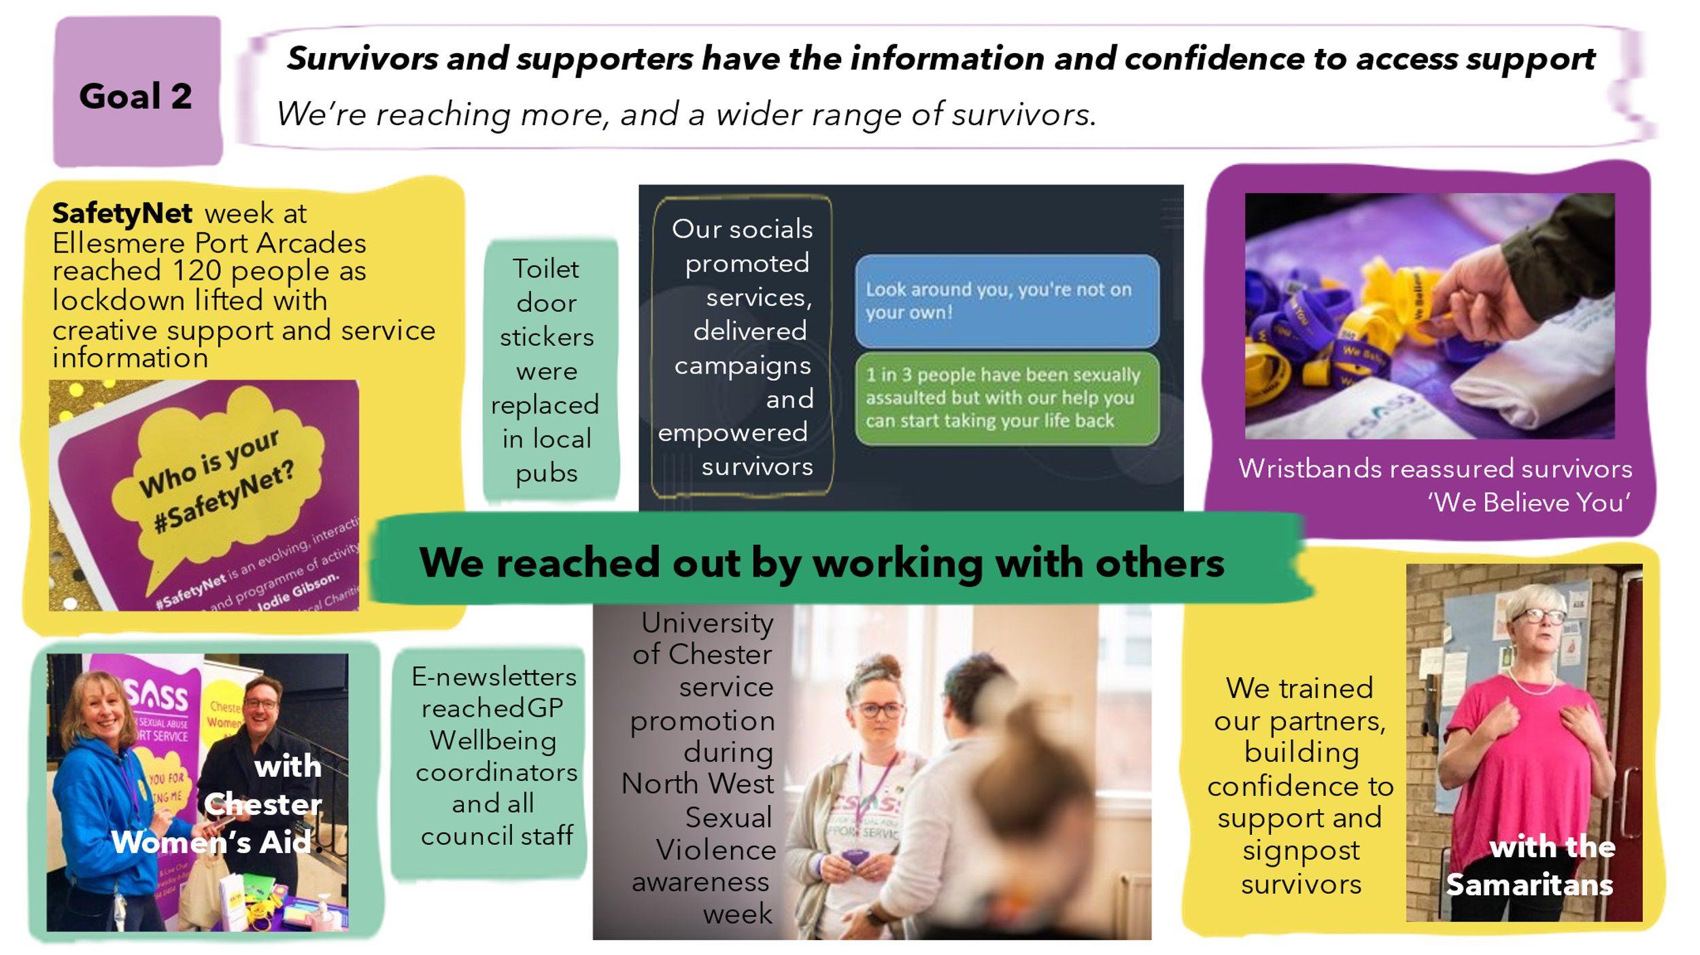

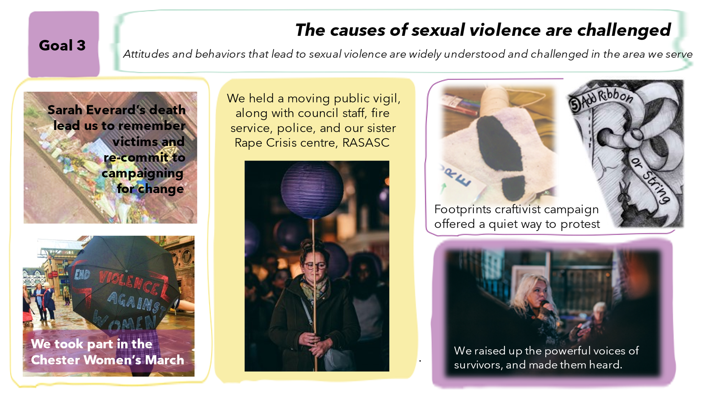
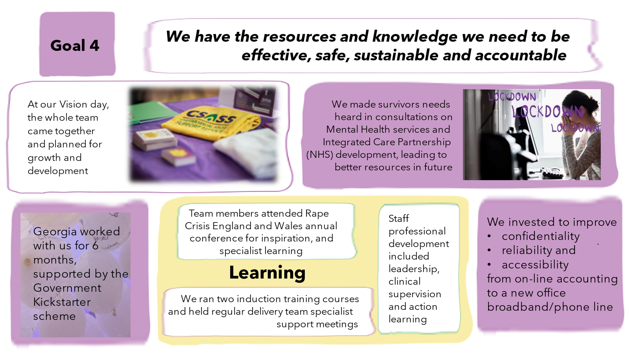
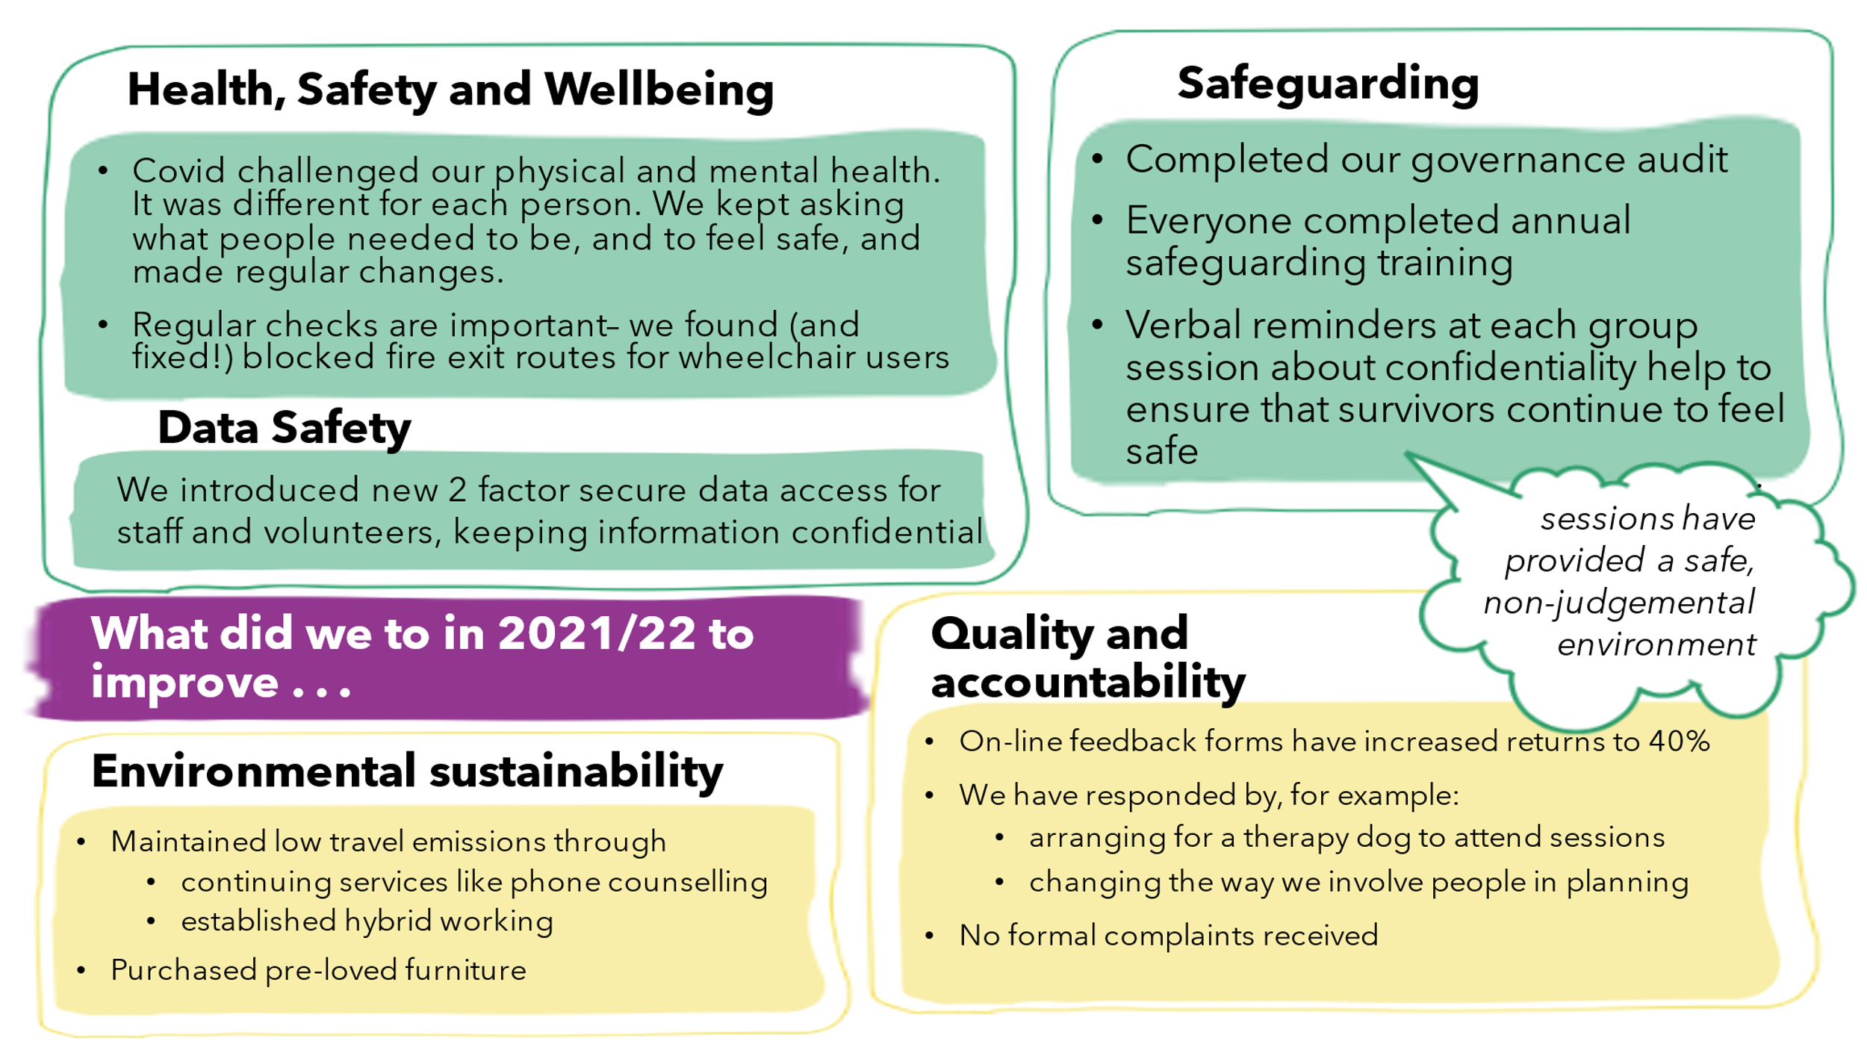
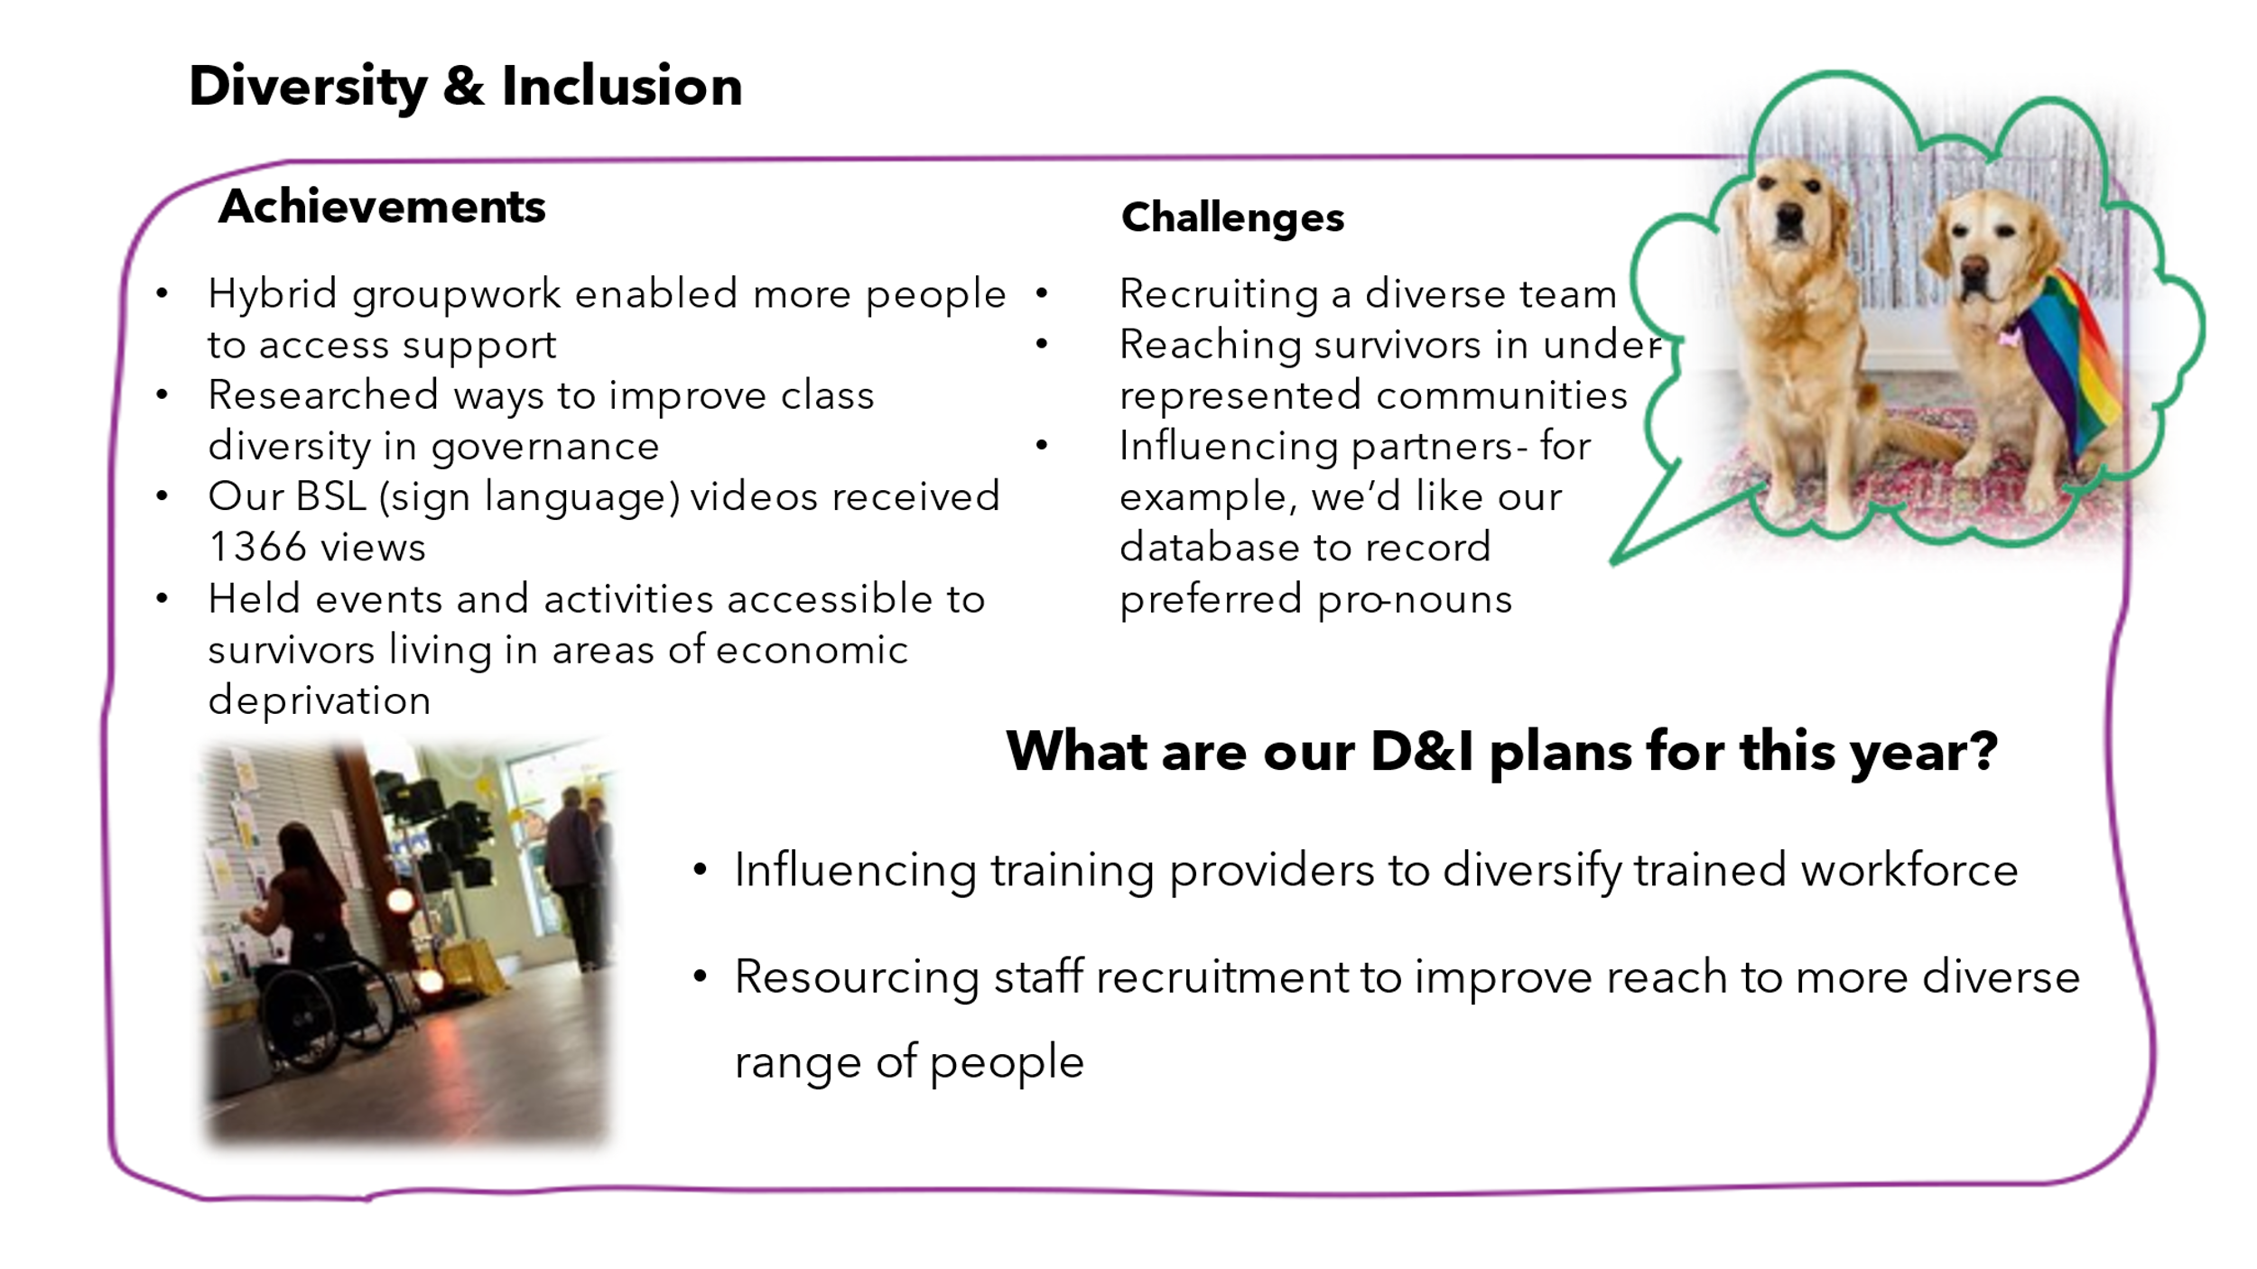
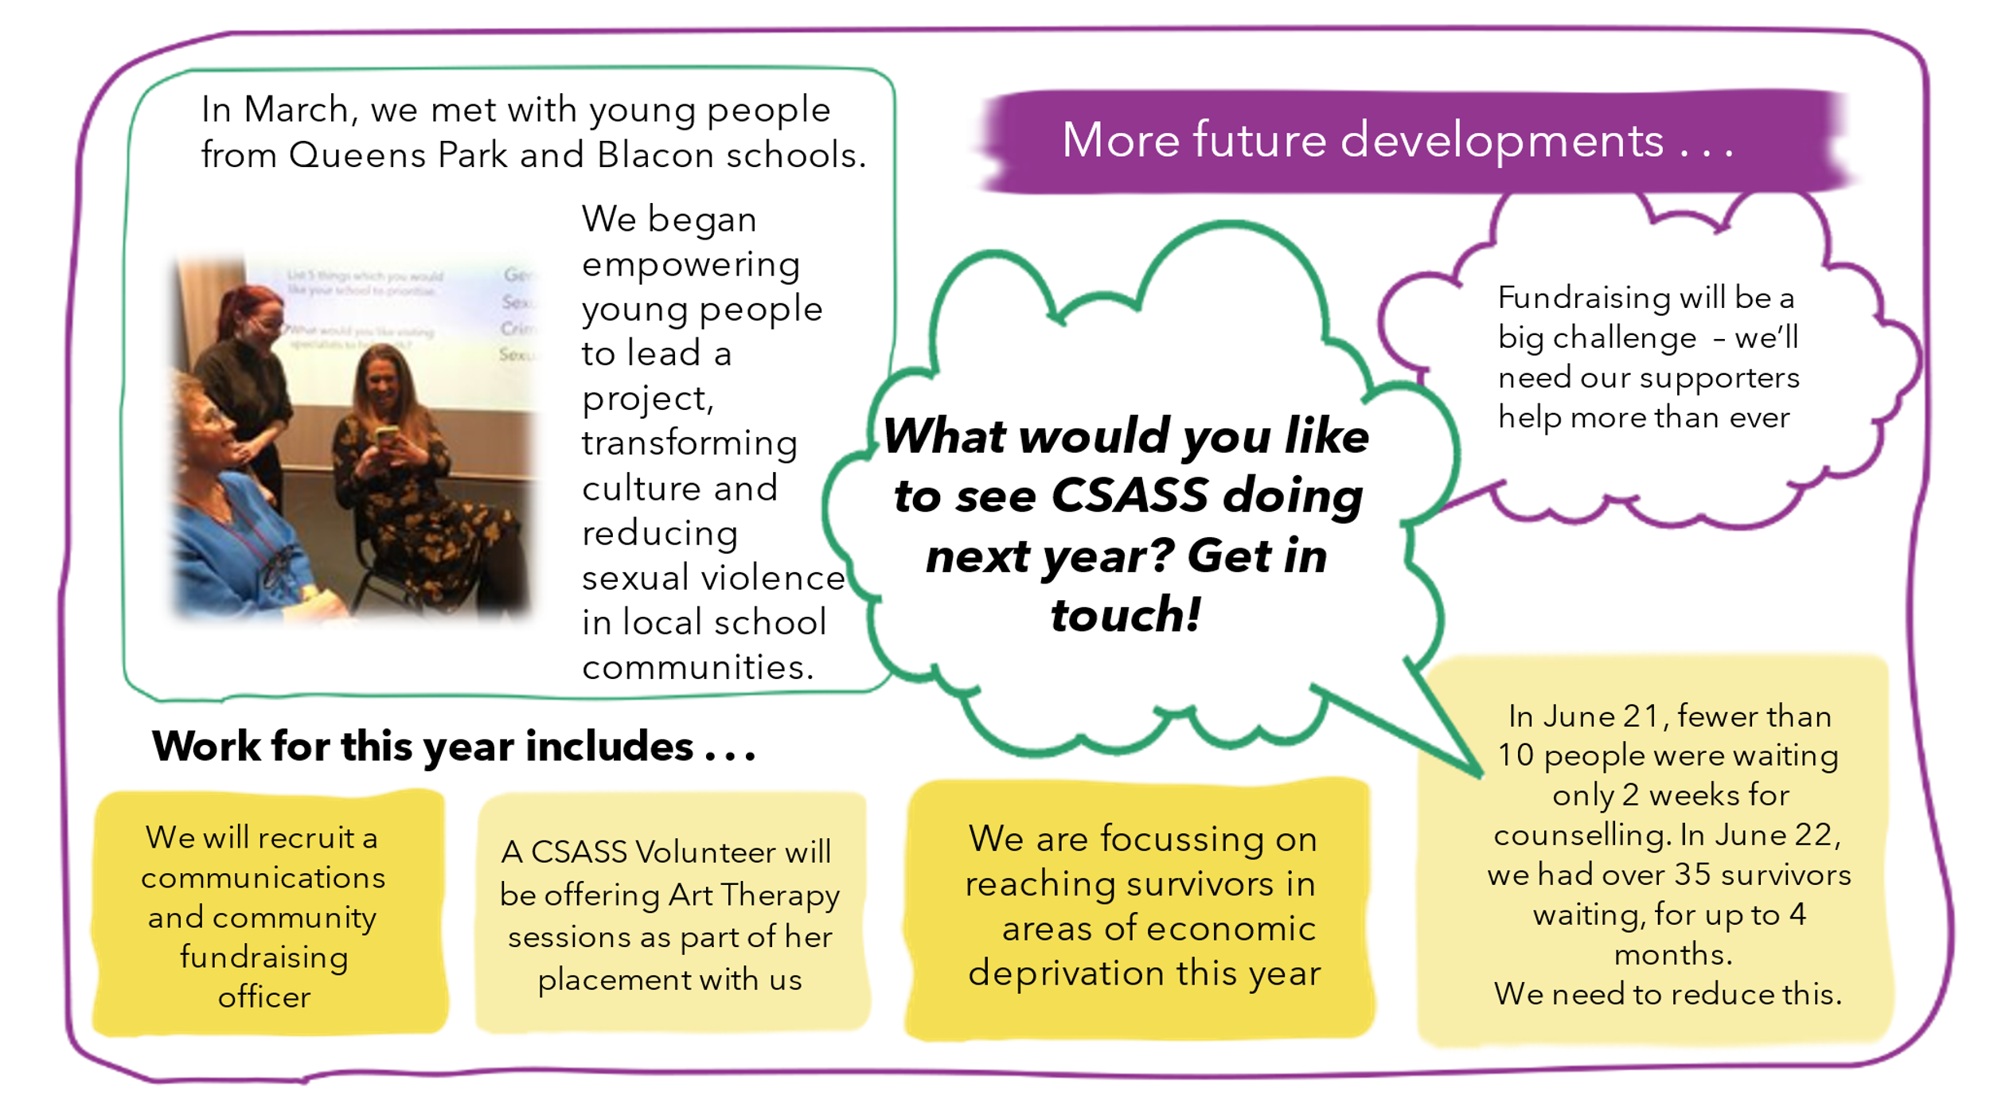

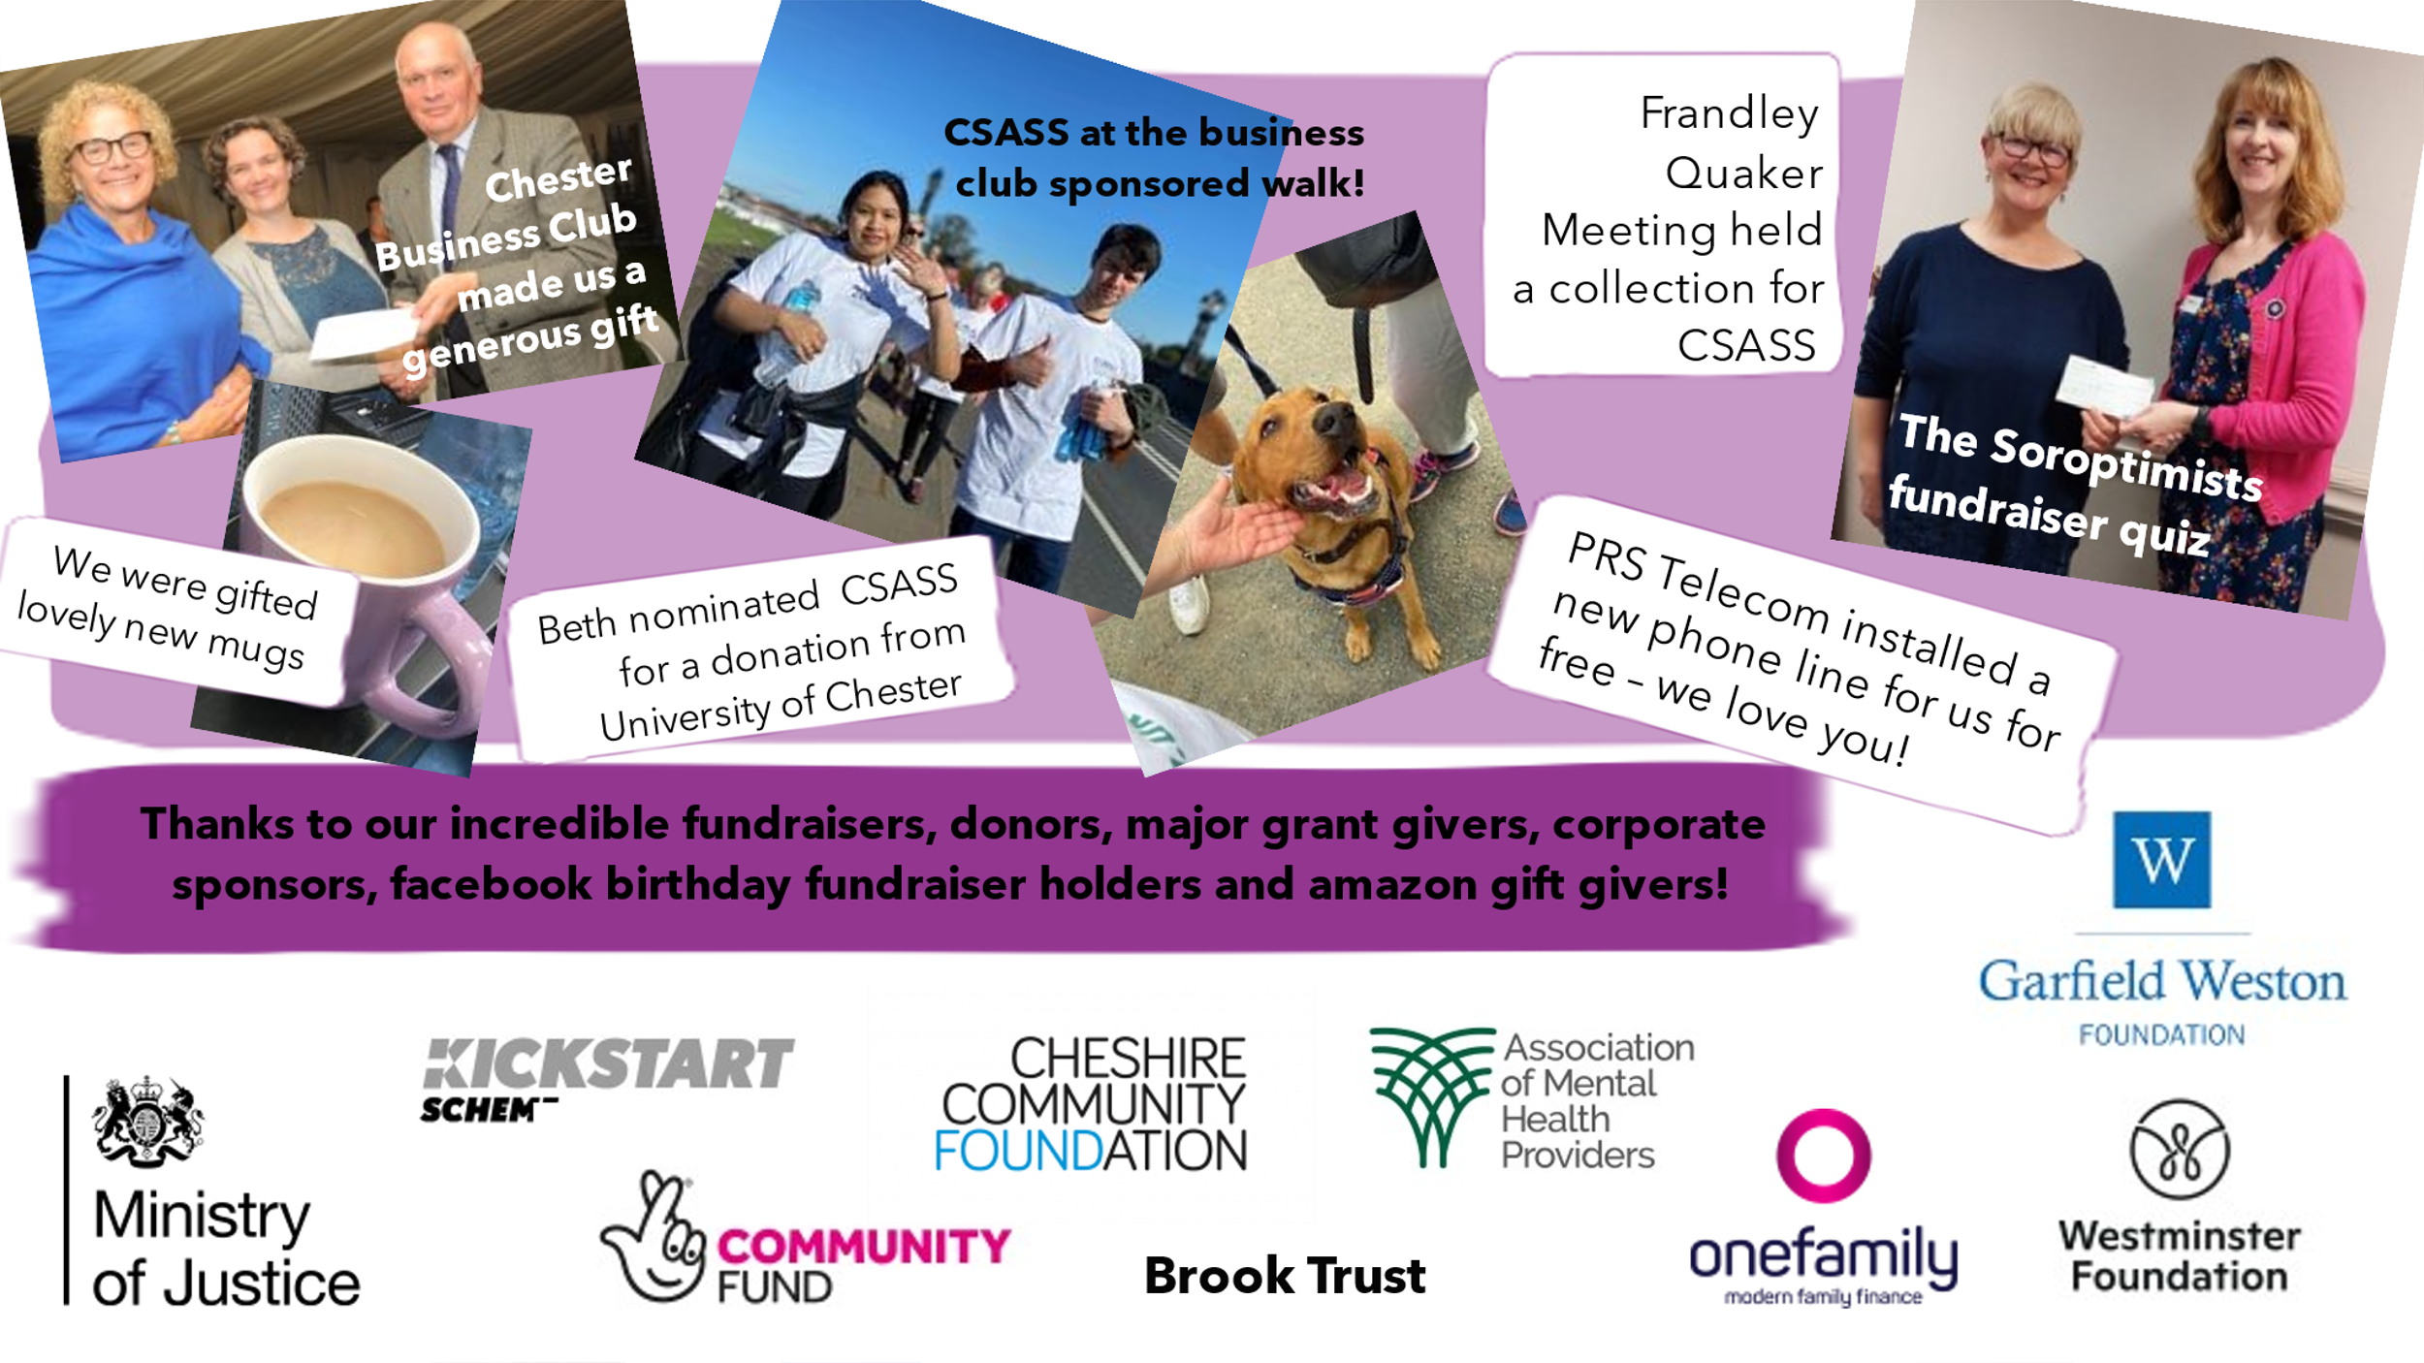
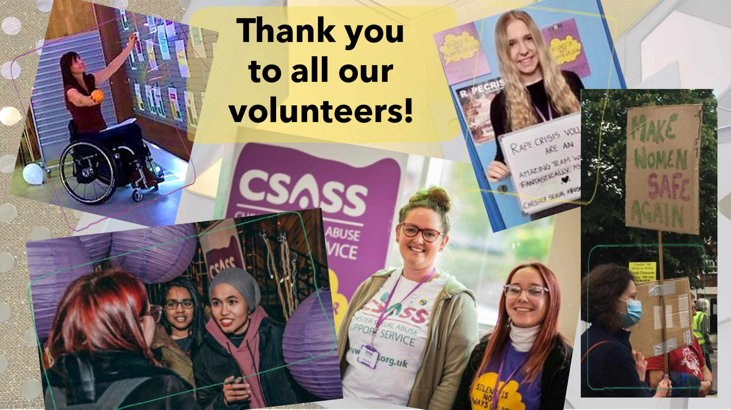

7. Our move to CIO

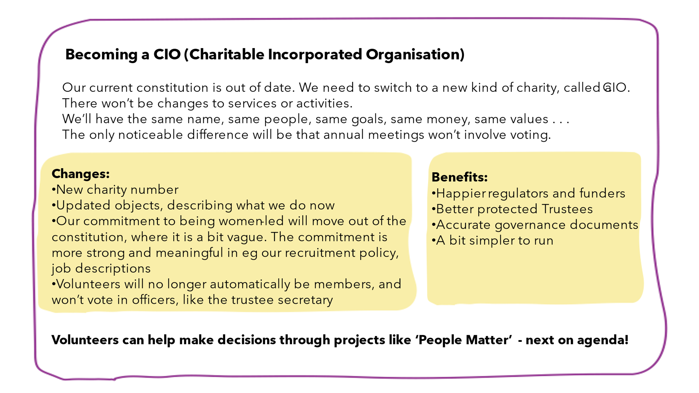
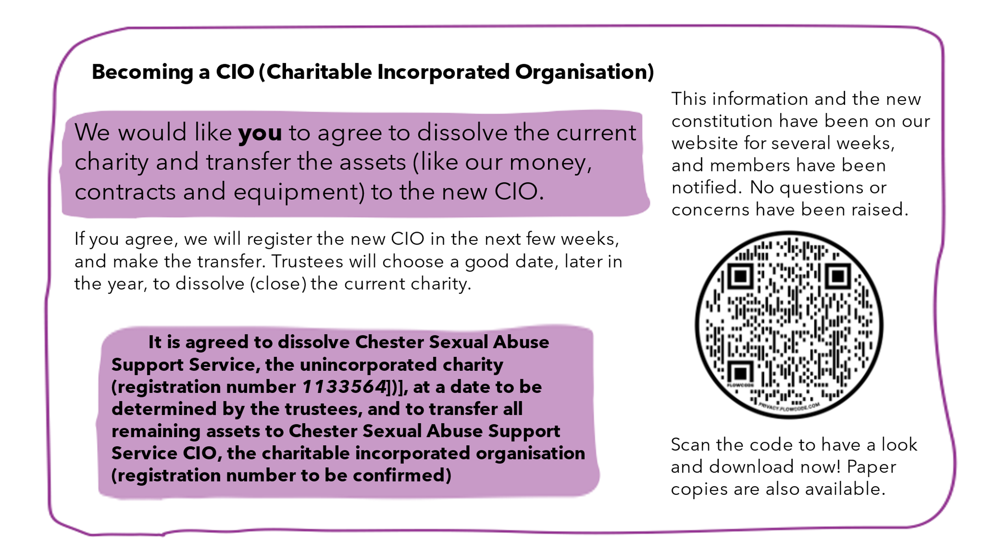
- People Matter launch
